Python 101
Project Title: Personal Finance Tracker
Project Description:
In this project, we will create a modern personal finance tracker using Python. The tracker will allow users to manage their income, expenses, and savings. It will provide a user-friendly interface for adding transactions, categorizing expenses, and generating reports.
Project Steps:

Step 1: Print Statement
Start by printing a welcome message and instructions for the user.
Step 2: Variables
Create variables to store income, expenses, savings, and transaction data. Consider using appropriate data structures like lists, dictionaries, or classes to organize the data effectively.
Step 3: Data Types
Determine the appropriate data types for each variable based on the requirements. For example, use floating-point numbers for currency amounts and strings for transaction descriptions.
Step 4: Input and Output
Design a user-friendly interface to input and display data. Use the input function to prompt the user for information and the print statement to present results.
Step 5: Functions
Implement functions for adding income, adding expenses, and calculating savings. Each function should update the relevant variables based on user input.
Step 6: Conditional Statements
Use conditional statements to provide different options to the user, such as adding income, adding expenses, generating reports, or exiting the program.
Step 7: File Handling
Store transaction data in a file to persist the information between program runs. Implement functions to read and write transaction data from/to a file.
Step 8: Categories and Reports
Allow the user to categorize expenses and generate reports based on categories, monthly summaries, or custom date ranges. Implement functions to calculate and display these reports.
Step 9: Data Visualization (Optional)
Use external libraries such as Matplotlib or Plotly to create graphical representations of financial data. Generate charts or graphs to visualize income, expenses, and savings over time.
Step 10: Error Handling and Validation
Implement error handling and validation mechanisms to handle incorrect inputs or invalid operations. Provide appropriate error messages and guide the user to enter the correct information.
Step 11: Test and Refine
Test the finance tracker by adding various transactions, checking reports, and ensuring the calculations are accurate. Refine the code based on user feedback and testing results.
Step 12: Conclusion
Print a closing message and thank the user for using the personal finance tracker.
BONUS: JSON Introduction
JSON (JavaScript Object Notation) is a lightweight data-interchange format that is easy for humans to read and write and easy for machines to parse and generate. It is widely used for data serialization and communication between web services and clients.
JSON Syntax:
JSON data is represented in key-value pairs.
Data is enclosed in curly braces {} and organized into multiple key-value pairs.
Each key is a string enclosed in double quotes, followed by a colon :, and the corresponding value.
Values can be strings, numbers, booleans, arrays, or nested objects.
Arrays are enclosed in square brackets [] and can contain multiple values separated by commas.
Nested objects are objects within objects, represented as key-value pairs within curly braces.
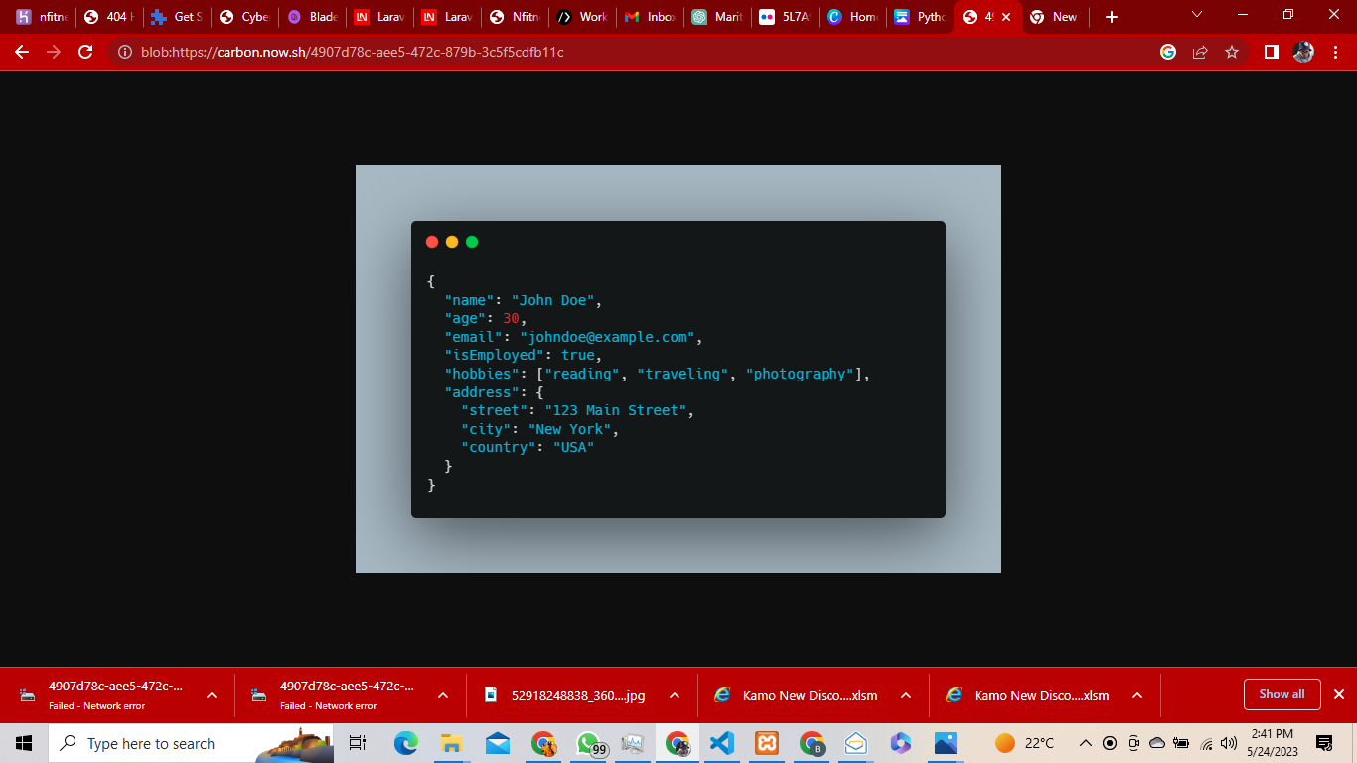

In the example above, we have a JSON object representing a person's information. It includes properties like name, age, email, isEmployed, hobbies (an array of strings), and address (a nested object with street, city, and country properties).

Python and JSON:
Python provides built-in libraries (JSON) to work with JSON data. These libraries allow you to convert JSON data to Python objects (deserialization) and Python objects to JSON data (serialization).
Using the JSON library, you can perform tasks such as:
Parsing JSON data from a file or string into Python objects using the json.loads() function.
Converting Python objects to JSON data using the json.dumps() function.
Reading and writing JSON data to files using the json.load() and json.dump() functions, respectively.

JSON is widely supported in various programming languages and is an efficient and flexible way to exchange data between different systems or components.

Note: This project can be expanded further by adding features like budgeting, goal tracking, data analysis, and integrating with external APIs for real-time currency exchange rates or financial information.

